Student applications in USOSweb

To go to the Applications module after logging in to USOSweb, click
STUDENT`S SECTION - Applications
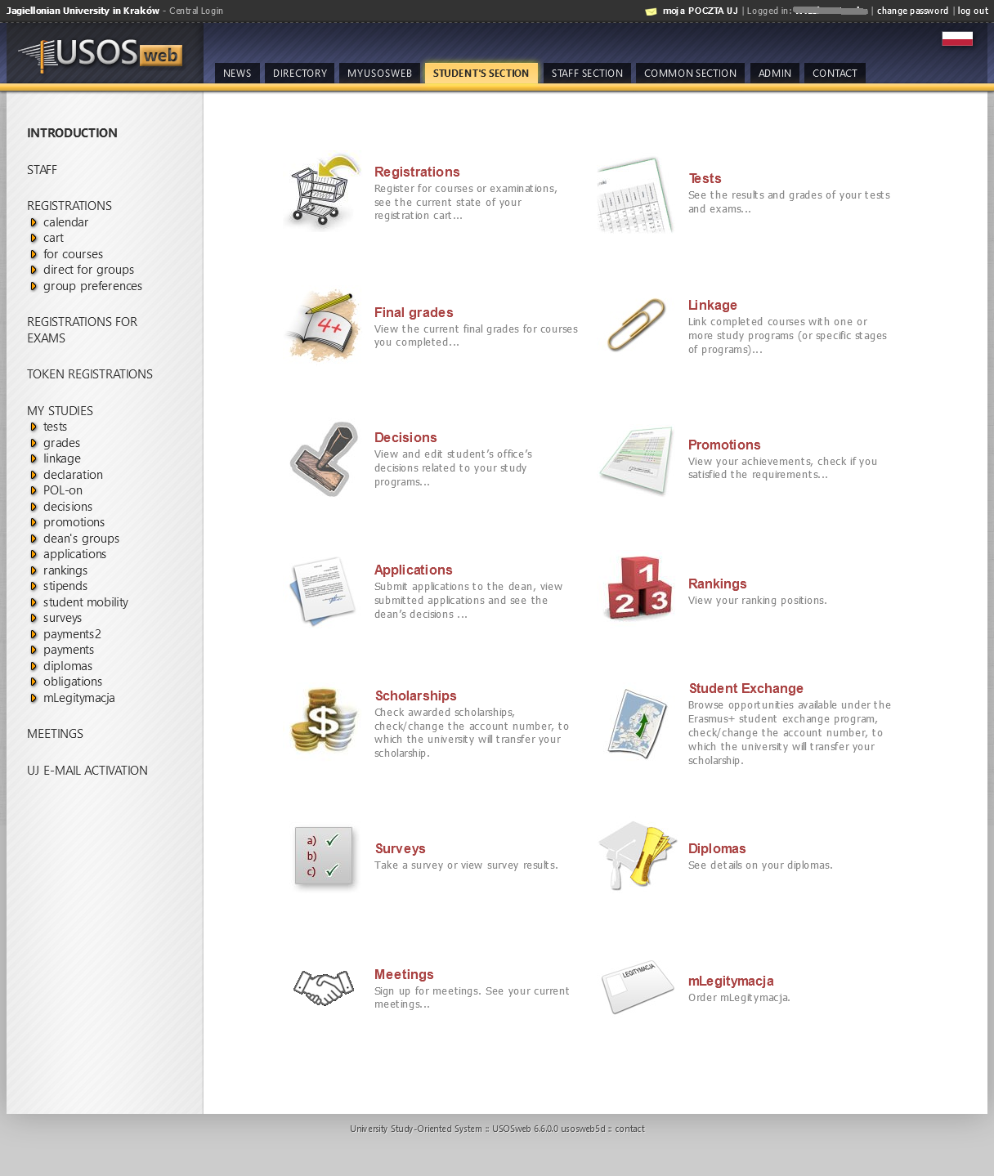

To apply click submit a new application

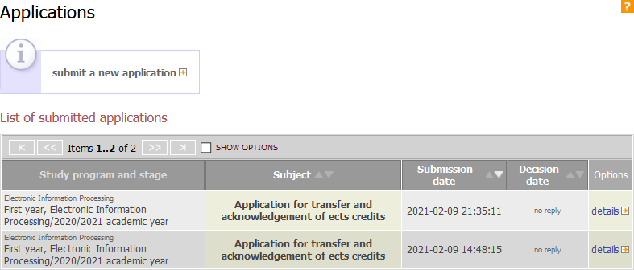

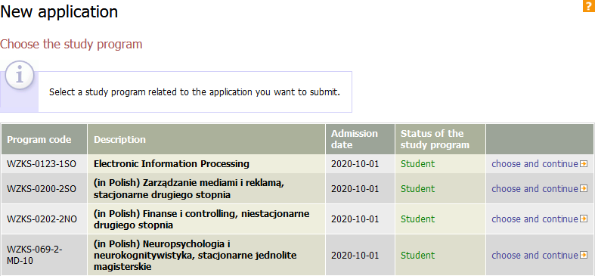
If you are studying more than one study program, choose the one to which you will apply – click choose and continue

A list of the available application types will appear. Just before submitting the application, read carefully the description in the Information section, which contains the requirements necessary for the case to be considered by the secretary, director or dean.

To apply click complete the application
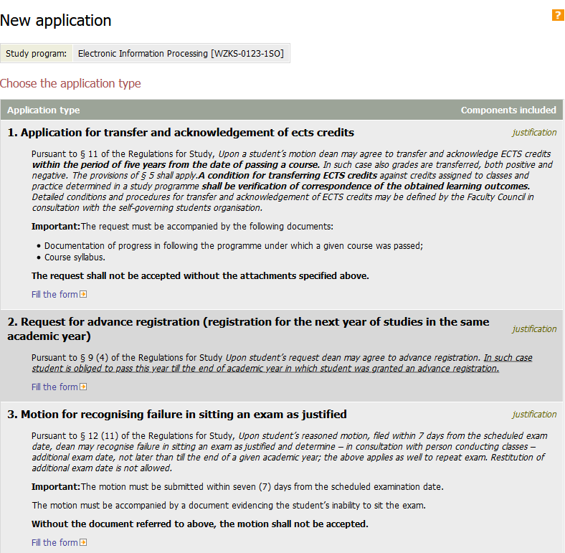

Enter the content of the application in the text field

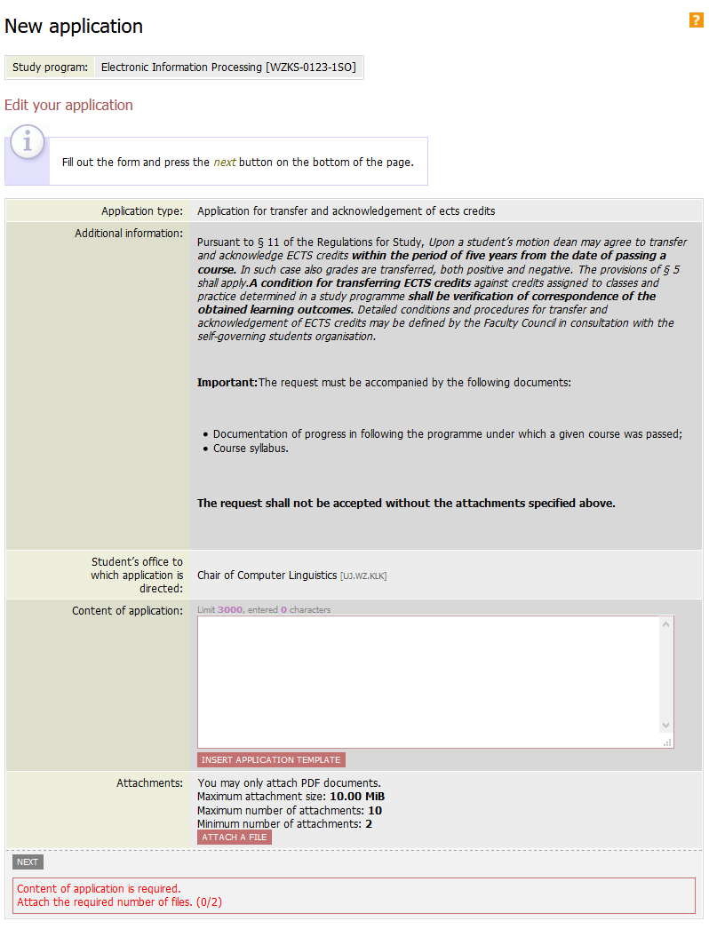
Start entering the content of the application by clicking Insert Application Template and then completing the missing elements in the template and removing unnecessary
textbox

After clicking insert application template, the system makes sure whether you want to replace the content of the text field with the content of the template

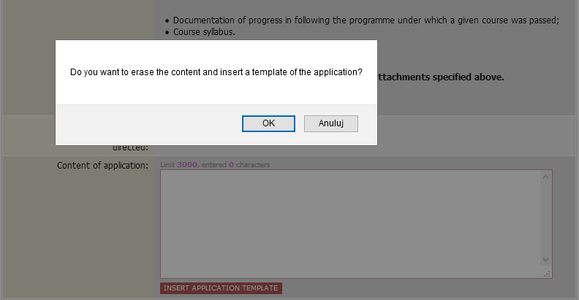
Expressing consent fills the text field with the content of the template and the number of required attachments is indicated in red at the bottom of the form without the system will not go Further
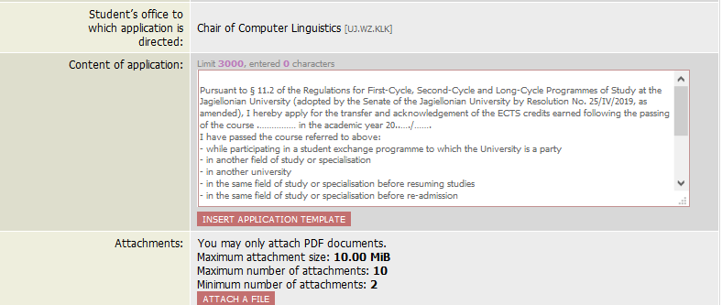

Attached files must be in pdf format and exactly described in the field next to the file name. The number of attached files may not be less than that required by the application
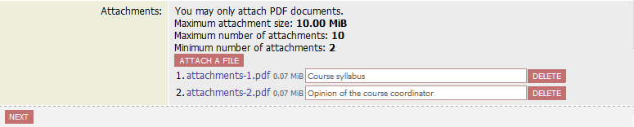
The edition is completed after clicking NEXT and displaying the summary of the submitted application
After checking the correctness of content of the application and the number of attachments, you can click CONFIRM or RETURN TO EDITING

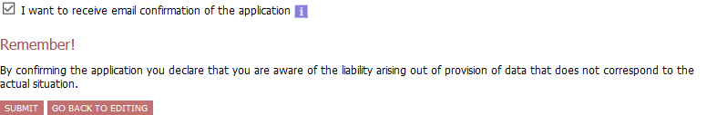
Selecting CONFIRM displays a message

Clicking Cancel withdraws from submitting the application, clicking OK results in submitting the application and sending an e-mail notification to the student's account and displaying the following information:
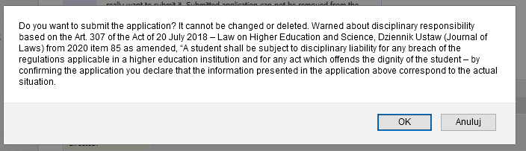

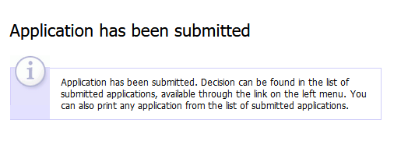
The application is automatically added to the list of submitted applications with the filing date.

To check the details of application, click on details

CAUTION:

The application submitted to USOSweb is visible by the secretary's office / dean's office only after the synchronization of the USOSweb with the main USOS database (every morning).

The answer given by the Director / Dean on a given day will appear in USOSweb after the next data synchronization.
.
Reply to the application

In the Application module there is a list of all submitted applications with the possibility of printing them, with the dates of their submission, consideration and details.
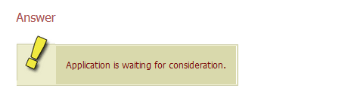
No date of consideration of the application with the entry "no answer" means:
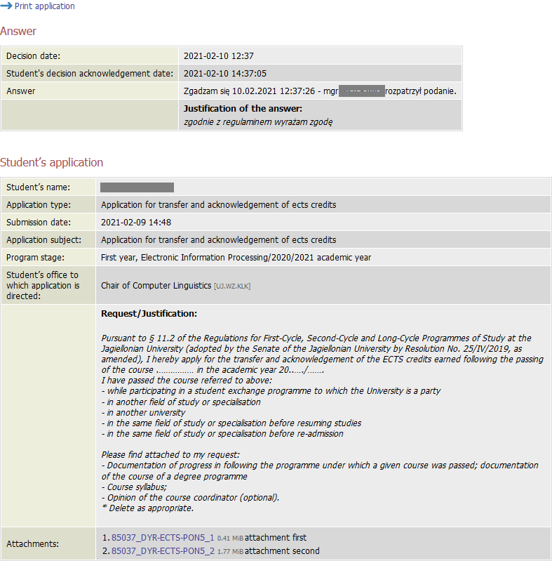
The considered application shows the "decision date", and "the answer of the dean / director” with details.
If the application has deficiencies, which were described in detail in the initial information, it will be sent to the student with a note to supplement the non-compliance and fill in a new application
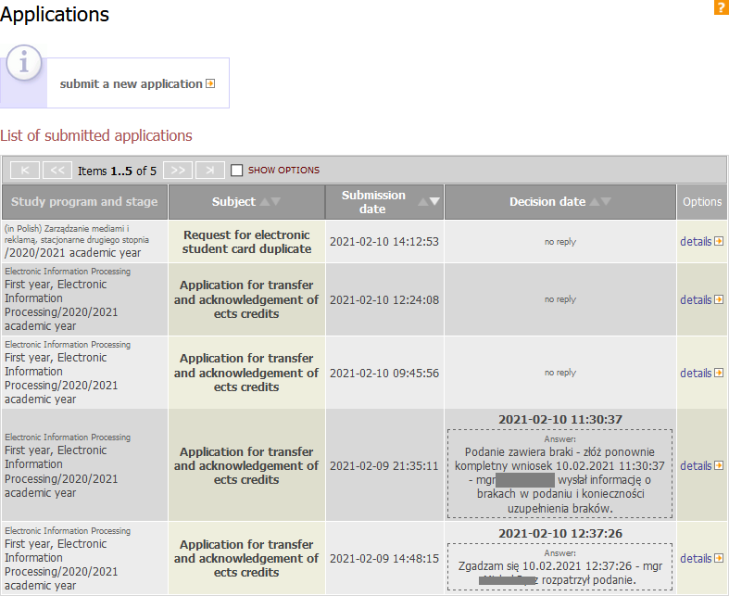

The returned application will contain the date of consideration with details of the problem and the case number, which should be added to the header of the new application in the form:
In response to procedural errors of application in No. .....

List of applications in USOSweb:

- NOTICE OF STUDENT’S LEAVE OF ABSENCE
- NOTICE OF TRANSFER TO ANOTHER UNIVERSITY
- NOTICE OF WITHDRAWAL FROM A DECLARED COURSE DUE TO CHANGE OF CLASS SCHEDULE
- REQUEST FOR ADVANCE REGISTRATION (REGISTRATION FOR THE NEXT YEAR OF STUDIES
IN THE SAME ACADEMIC YEAR)
- REQUEST FOR COMMISSION EXAMINATION
- MOTION FOR DEAN’S LEAVE
- MOTION FOR RECOGNISING FAILURE IN SITTING AN EXAM AS JUSTIFIED
- REQUEST FOR CONDITIONAL REGISTRATIOHN FOR THE NEXT YEAR OF STUDIES
- REQUEST FOR REGISTRATION AFTER DEAN’S/STUDENT LEAVE
- REQUEST FOR ELECTRONIC STUDENT CARD DUPLICATE
- REQUEST FOR ELECTRONIC STUDENT CARD REPLACEMENT
- REQUEST FOR INDIVIDUAL STUDY PLAN
- REQUEST FOR CONSENT FOR ANOTHER REPETITION OF A YEAR OF STUDY
- REQUEST FOR CONSENT TO REPEAT A YEAR OF STUDY
- APPLICATION FOR TRANSFER AND ACKNOWLEDGEMENT OF ECTS CREDITS
- REQUEST FOR CONSENT TO TAKE HIGHER-YEAR COURSES
- REQUEST FOR CONSENT TO DETERMINE THE THIRD EXAM DATE FOR A GIVEN COURSE DURING THE SAME ACADEMIC YEAR
- REQUEST FOR CONSENT TO PASS COURSES NOT COVERED BY STUDY PROGRAMME/PERFORM PART OF THE STUDY PROGRAMME IN OTHER HIGHER EDUCATION INSTITUTIONS, INCLUDING THOSE ABROAD
- REQUEST FOR CONSENT TO CHANGE SUPERVISOR OF DIPLOMA THESIS
- REQUEST FOR AWARDING CREDIT FOR PRACTICE BY STUDENT WHO HAS CONFIRMED EXPERIENCE CORRESPONDING TO AIMS AND OUTCOMES OF PRACTICE
- REQUEST FOR AWARDING CREDIT FOR PRACTICE BY STUDENT WHO HAS CONFIRMED EXPERIENCE CORRESPONDING TO AIMS AND OUTCOMES OF PRACTICE

